Title of paper
Sub-title of paper (if any)

Author Name 1
Affiliation, e-mail
Author Name 2
Financial Geography Working Paper #1
Affiliation, e-mail
Etc.

Month, Year
If you need to add any funding details, please add them here but keep it short. No acknowledgements here.

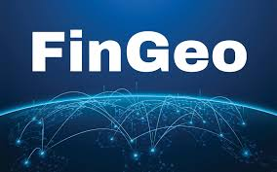

Title of paper in Arial 16 (not bolded)

Abstract title in Arial 14 (not bolded)
Abstract text in Arial 12.

Section title in Arial 14 (not bolded)
Text text text text text text text text text text text text text text text text text text text text text text text text text
Next paragraph: text text text text text text text text text text text text text text text text

Section sub-title in Arial 12 in italics
Text in Arial 11.

Section sub-title in Arial 12 in italics
Text in Arial 11.

Section title in Arial 14 (not bolded)
Text

Acknowledgments title in Arial 14 (not bolded)
Text

References (heading in Arial 14, not bolded)
Reference 1: Text text text text text text text text text text text text text text text text text text text text text text text
Reference 2: Text in Arial 11. Same format as general text (except that indenting is replaced by hanging paragraphs (1cm).
Etc.

The Real Estate/Financial Complex (REFCOM)
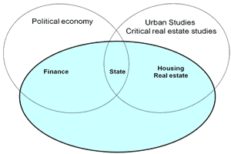
Real estate and finance were at the roots of the global economic crisis that started in 2007. States and their many institutions have also been seen as complicit to the crisis. The connections between real estate (both residential and non-residential), finance and states still remain under-researched and under-theorized. Work in various political economy traditions has done a great deal of research into the connection between finance and states, but they have often ignored a crucial sector: real estate. There is also a tradition of work focusing on the interaction between real estate and states, usually concentrating on the involvement of municipalities in real estate projects. Finance is often ignored in this tradition. Moreover, this tradition has its roots in urban studies and is very micro focused, while the various political economy traditions are very macro focused. In other words, we not only need a stronger connection between finance and real estate, we also need a stronger connection between different scales: local/urban, national and global.
We here propose a new metaphor that can help us to centre attention on the connection between real estate, finance and states: the real estate/financial complex, akin the military/industrial complex. Both complexes should be seen as triangles since states are also part of the equation. This is an internationally comparative research project, with case studies in Europe, Asia and the Americas, focusing on the different scales of the real estate/financial complex, from urban projects to national structures and from firms to global markets.
This research project is made possible by Starter Grant number 313376 of the European Research Council (ERC) and additional funding by the KU Leuven / University of Leuven and is further expanded through a Joint PhD programme with Politecnico di Milano. Together, we will map the Real Estate/Financial Complex in: Belgium, Brazil, China (both Mainland and Hong Kong), France, Germany, Italy, the Netherlands, Russia, Spain, Poland, United Kingdom and United States.

More information here: http://ees.kuleuven.be/refcom
And: http://www.facebook.com/REFcomplex

